Sales Project Report
- TOTAL_REVENUE
select sum(TOTAL_PRICE) AS TOTAL_REVENUE FROM sales_data
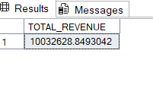
- AVG_ORDER_VALUE
SELECT SUM(TOTAL_PRICE)/COUNT(DISTINCT ORDER_ID) AS AVG_ORDER_VALUE FROM sales_data

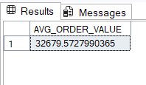
- TOTAL_PRODUCT_SOLD
SELECT SUM(QUANTITY) AS TOTAL_PRODUCT_SOLD FROM sales_data
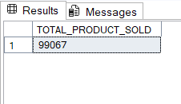

- TOTAL_ORDERS_SOLD
SELECT COUNT(DISTINCT ORDER_ID) AS TOTAL_ORDERS_SOLD FROM sales_data
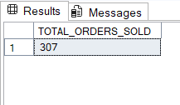

- AVG_PRODUCT_PER_ORDERS
SELECT CAST(CAST(SUM(QUANTITY)AS decimal(10,2))/CAST(COUNT(DISTINCT ORDER_ID) AS decimal(10,2))AS decimal(10,2))AS AVG_PRODUCT_PER_ORDERS FROM sales_data
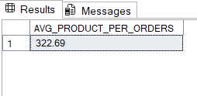

- MONTHLY TREND
SELECT DATEPART(MONTH,ORDERDATE) AS ORDER_MONTHS,
COUNT(DISTINCT ORDER_ID) AS TOTAL_ORDERS
FROM sales_data
GROUP BY DATEPART(MONTH,ORDERDATE) ;
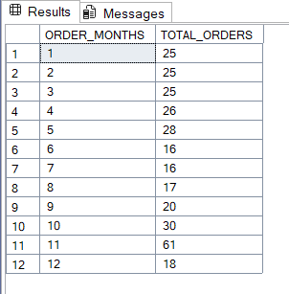

- YEARL TREND
SELECT DATEPART(YEAR,ORDERDATE) AS ORDER_YEAR,
COUNT(DISTINCT ORDER_ID) AS TOTAL_ORDERS
FROM sales_data
GROUP BY DATEPART(YEAR,ORDERDATE) ;
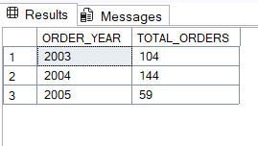

- PERCENTAGE OF SALES BY PRODUCT CATEGORY
SELECT CATEGORY, CAST(SUM(TOTAL_PRICE)*100/
(SELECT SUM(TOTAL_PRICE) FROM sales_data
WHERE MONTH(ORDERDATE)=1) AS decimal(10,2)) PCT
FROM sales_data
GROUP BY CATEGORY
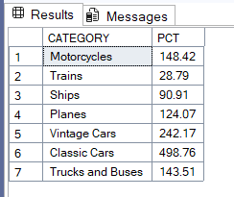

- PERCENTAGE OF SALES BY SIZE
SELECT DEALSIZE,CAST(SUM(TOTAL_PRICE)
AS decimal(10,2)) AS TOTAL_SALES,
CAST(SUM(TOTAL_PRICE)*100/
(SELECT SUM(TOTAL_PRICE)
FROM sales_data) AS DECIMAL(10,2)) AS PCT
FROM sales_data GROUP BY DEALSIZE
ORDER BY PCT
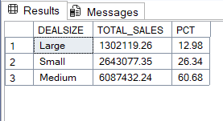

- TOTAL PRODUCT SOLD BY PRODUCT CATEGORY
SELECT CATEGORY,SUM(QUANTITY) AS PRODUCT_SOLD_BY_CATEGORY FROM sales_data GROUP BY CATEGORY
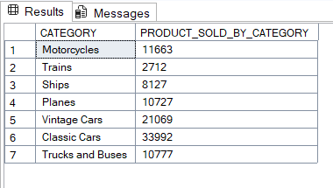

- TOP 5 CUSTOMER BY TOTAL PRODUCT SOLD
SELECT TOP 5 CUSTOMERNAME, SUM(QUANTITY) AS TOTAL_PRODUCT_SOLD
FROM sales_data
GROUP BY CUSTOMERNAME
ORDER BY SUM(QUANTITY) DESC
